实验一

1. 进入系统，并连接网络（图中红色部分为网络连接标识）

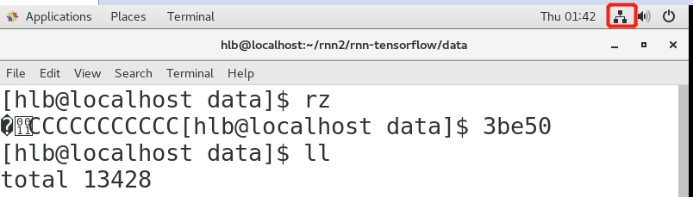

1. 使用“ll”命令查看当前文件目录
2. 使用“mkdir 文件名”新建文件夹
3. 使用“git clone <https://github.com/hzy46/Char-RNN-TensorFlow> 文件名”将远程文件克隆到本地指定文件夹下（注意：需先使用“yum install git”命令安装git，需要root权限）
4. 输入训练命令：（可以自行改参数，以获得更好的训练模型）

python train.py \

--input_file data/jay.txt \

--num_steps 20 \

--batch_size 32 \

--name jay \

--max_steps 5000 \

--learning_rate 0.01 \

--num_layers 3 \

--use_embedding

1. 输入sampling命令：

python sample.py --converter_path model/jay/converter.pkl \

--checkpoint_path model/jay \

--max_length 500 \

--use_embedding \

--num_layers 3 \

--start_string 我知道

1. 查看sampling结果
2. 其他数据源的train及sampling命令示例
3. **Generate English Text**

To train:

python train.py \

--input_file data/shakespeare.txt \

--name shakespeare \

--num_steps 50 \

--num_seqs 32 \

--learning_rate 0.01 \

--max_steps 20000

To sample:

python sample.py \

--converter_path model/shakespeare/converter.pkl \

--checkpoint_path model/shakespeare/ \

--max_length 1000

（2）**Generate Chinese Poetries**

To train:

python train.py \

--use_embedding \

--input_file data/poetry.txt \

--name poetry \

--learning_rate 0.005 \

--num_steps 26 \

--num_seqs 32 \

--max_steps 10000

To sample:

python sample.py \

--use_embedding \

--converter_path model/poetry/converter.pkl \

--checkpoint_path model/poetry/ \

--max_length 300

（3）**Generate Chinese Novels**

To train (The file "novel.txt" is not included in this repo. You should find one and make sure it is utf-8 encoded!):

python train.py \

--use_embedding True \

--input_file data/novel.txt \

--num_steps 80 \

--name novel \

--learning_rate 0.005 \

--num_seqs 32 \

--num_layers 3 \

--embedding_size 256 \

--lstm_size 256 \

--max_steps 1000000

To sample:

python sample.py \

--converter_path model/novel/converter.pkl \

--checkpoint_path model/novel \

--use_embedding \

--max_length 2000 \

--num_layers 3 \

--lstm_size 256 \

--embedding_size 256

（4）**Generate Linux Code**

To train:

python train.py \

--input_file data/linux.txt \

--num_steps 100 \

--name linux \

--learning_rate 0.01 \

--num_seqs 32 \

--max_steps 20000

To sample:

python sample.py \

--converter_path model/linux/converter.pkl \

--checkpoint_path model/linux \

--max_length 1000

（5）**Generate Japanese Text**

To train:

python train.py \

--input_file data/jpn.txt \

--num_steps 20 \

--batch_size 32 \

--name jpn \

--max_steps 10000 \

--learning_rate 0.01 \

--use_embedding

To sample:

python sample.py \

--converter_path model/jpn/converter.pkl \

--checkpoint_path model/jpn \

--max_length 1000 \

--use_embedding